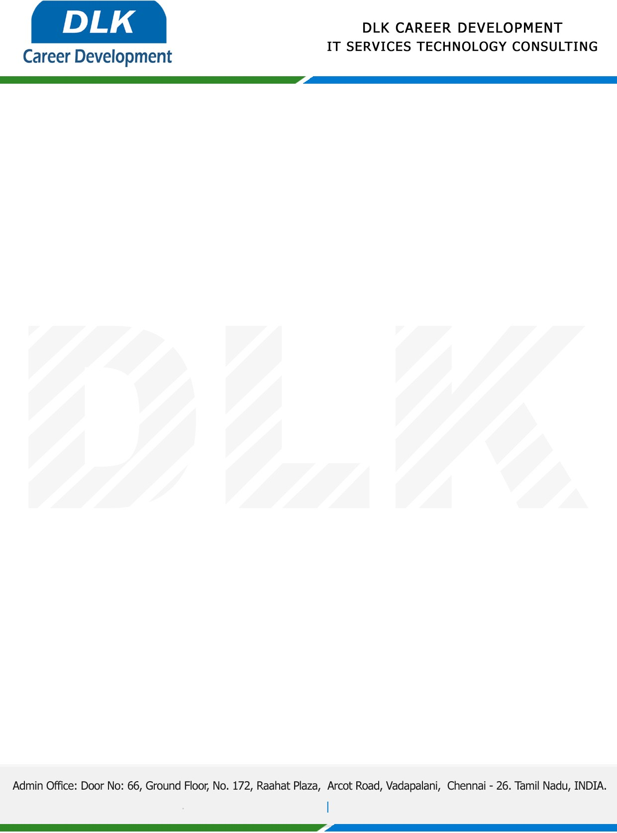

Date: 31/ December / 2022

**To**

Department of BE ([Computer Science Engineering),](https://www.cseindia.org/)

Head of Department,

Velammal Engineering College, Chennai - 600066.

**Sub: Letter of Internship Acceptance**

This is to certify that **MR SANTHOSHKUMAR S (REG NO: 113220031120)** third year student of has accepted his Internship Work duration from **02nd January 2023** to **20th January 2023** under the domain” **Web Development”.** During the internship, all information and data collected from your should be kept confidential.

We appreciate your interest in **DLK CAREER DEVELOPMENT**

